
https://atlas.cid.harvard.edu/

Optimal Industry Development Strategy Using Economic and Product Complexity

Chile

─
The Economic Complexity Lab - Columbia University
Alexandra Garcia, Kelly Mi, Margarita Demkina, Allison Lin, Helena Yang, Jane Zhang, Daniel Xu, Ryo Shibata, Haoxian Chen, Davepriyan Gunaratnam, Rohan Macherla, Ajit Akole, Shomik Ghose, Alex Wei-Liang Ku, Sannidhya Modi, Xilin Wang

Optimal Industry Development Strategy for Chile

0. Executive Summary

In this report, we aim to uncover the economic path Chile went through during the period from 2013 to 2022. Specifically, we dive into the topic through a macroeconomic overview of Chile from the perspective of Gross Domestic Product (GDP) and Economic Complexity Index (ECI), which reflect countries’ production capability and production structure, respectively. We divide the period into two subperiods: 2013-2018 and 2019-2022. These subperiods are meant to capture differences in pre- and post-pandemic economic progress and resulting optimal development path. We find that during the period of our interest, Chile demonstrated a moderate level of economic growth with an average annual GDP growth rate of 3.09% between 2013 and 2018 and 2.78% between 2019 and 2021, with a increased economic complexity compared to other major emerging economies.

The moderate progress during this period, we believe, can be partially explained through analysis of the economic and product complexity structure of Chile on the industry group level. The product classification system we adopt allows us to measure the realized industry development for various industry groups and to observe that Chile consistently relied on developing the Services and Utilities and Transportation industries in 2013 to 2018, and Precious Stones and Machinery and Construction in 2019 to 2022 while its developed counterparts and emerging economies around the globe adopted much more complex and progressive paths.

Based on our analysis of the opportunity gain and sensitivity analysis of major industry groups, Chile could further its gains by prioritizing Services and Utilities and Chemical Manufacturing and Precious Stones in 2018. Its development strategy in recent years is partially aligned with our previous recommendations, especially with Precious Stones, which we attribute to the increase in ECI. Four years later, in 2022, its focus should shift to Machinery and Construction and continue investing in Precious Stones. We further note that Chile has a slightly mismatched but improving development strategy that indicates a moderate level (compared to other emerging countries) of structural optimality on the complexity level, having an adjusted R-square of around 3.34% in 2018 and a much higher score of 11.3% in 2022, demonstrating improvement in development. Since a significant positive correlation exists between GDP growth and the structural optimality index of an economy as we define and calculate, Chile indeed has an optimal growth experience as compared with fast-growing economies both on a regional scale and on a global scale and has the potential to further its economic gains through industrial structure optimization as suggested in the paper.

The four years between 2019 and 2022 showed a significant improvement in Chile's economic growth, boosting its position on the global scale. Its GDP recovered to above the pre-pandemic levels, and it saw a significant boost in the ECI, particularly compared to its peer countries. Its current strategy still has the viable potential upside to increase its performance and optimize its structure further.

1. Report Overview

In this report, we aim to uncover the economic path Chile went through during the period from 2019 to 2022, after the COVID pandemic, compared to its performance from 2013 to 2018, before the pandemic. Specifically, we dive into the topic through a macroeconomic overview of Chile from the perspective of Gross Domestic Product (GDP) and Economic Complexity Index (ECI), which reflect countries’ production capability and production structure, respectively. We then analyze the industrial framework and changes of Chile during the period based on quantitative measures such as the Product Complexity Index (PCI) and Product Family Complexity Index (PfCI), followed by a detailed analysis of how such changes have matched with development strategies as quantitatively measured by opportunity gains on an industry-level. We conclude our report with macro-level results and predictions of Chile, as deduced from regression models we have established on a global scale, which take into account countries’ stances in their product space.

2. Macroeconomic Results

2.1 GDP Ranking and Changes
Figure 1a illustrates the time-series GDP results for Chile and three of its peer countries (the Argentina, Bolivia, and Peru) from 2013-2018. Chile displays consistent growth in small increments, a pattern similar to its peers with the exception of Argentina, which is slightly more volatile. Chile’s average annual growth rate of 3.09% over the five-year period is distinctly lower than both its closest peer, Peru (4.13%), and the lower-magnitude-GDP Bolivia (5.29%). However, its growth rate is much closer to these two countries than to Argentina (1.12%).

Figure 1b shows the GDP levels for Chile and the same peer countries from 2019 to 2022. Similar to the other countries, Chile displayed a drop in GDP from 2019 to 2020 because of the pandemic, with all GDPs rebounding in 2021. Over these three years, Chile’s average annual GDP growth rate (2.78%) is moderate, as it is greater than Peru’s rate (1.99%) and Bolivia’s (1.62%) but less than Argentina’s (10.58%). It is notable that only Chile’s GDP dropped in 2022, possibly due to changes in presidency and political unrest.

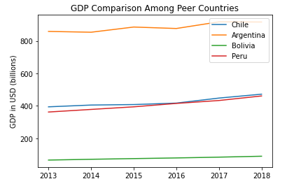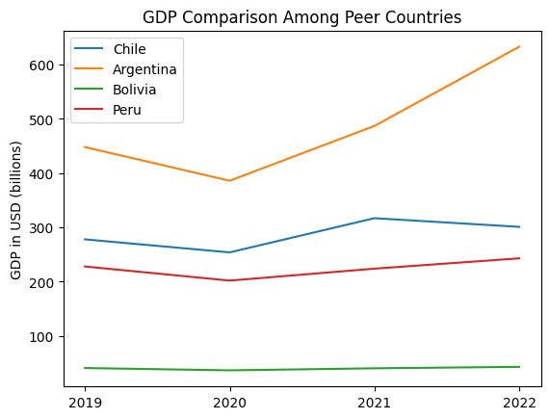
Figures 1a and 1b. GDP Comparison Among Peer Countries (left: 2013-2018; right: 2019-2022)

2.2 ECI Ranking and Changes
The Economic Complexity Index (ECI), as defined by Ricardo Hausmann and Cesar Hidalgo in 2009 to explain the knowledge accumulated in a country's population, is illustrated in Figures 2a and 2b.

As illustrated in Figure 2a below, Chile exhibits a significant decrease (-50.24% ECI change) in terms of its production capability from 2013 to 2018, which is similar to Argentina (-33.91%) but sharply lower than both Peru (-1.76%) and Bolivia (23.23%). The large ECI (and ECI change) contrast between Chile and Peru, which are peers in terms of GDP, is vital to note.

The comparable countries maintain a small change in ECI level between 2019 and 2020, with a sharp change between 2020 and 2021. Chile exhibits a large increase in production capability in 2021 to levels not seen prior, with a fiscal stimulus worth 4.7% of its GDP in response to the pandemic being one of the reasons. Chile has seen a 209.9% increase in its ECI, which is greater than Bolivia’'s (196.67%), Peru’s (181.1%), and Argentina’s (86.46%).

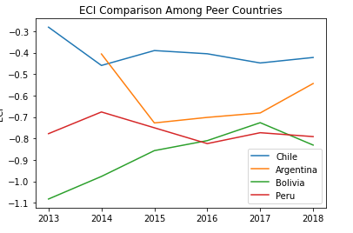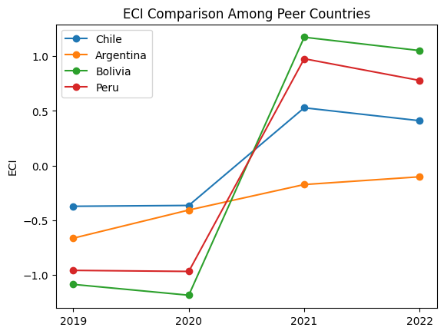
Figures 2a and 2b. ECI Comparison Among Peer Countries (left: 2013-2018; right: 2019-2022)

Figure 3a and 3b offers a further comparison of GDP Growth and ECI over the time span from 2013 to 2022 for Chile. The increasing-higher-rate increase in GDP growth during the period from 2013 to 2018 is accompanied by a volatile eventual decrease in ECI. The results show that the economic growth experienced by Chile during the period from 2013 to 2018 is partially consistent with the predictions by ECI and that Chile’s ability to develop a competitive product space that helped to accumulate complicated knowledge and technology declined as growth occurred. Unlike the volatile changes in GDP and ECI from 2013-2018, Chile experience more cohesive, positive growth between 2019-2022. It made strong progress towards effectively developing a competitive product space that helps to accumulate complicated knowledge and technology. For the period 2019 to 2022, the ECI followed GDP trends, which can be interpreted as advancements in production. In order to provide a more concrete answer to why this has happened, we will dive into an analysis of Chile’s production structure and its product space designs in the next few chapters.

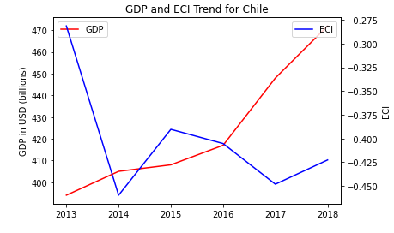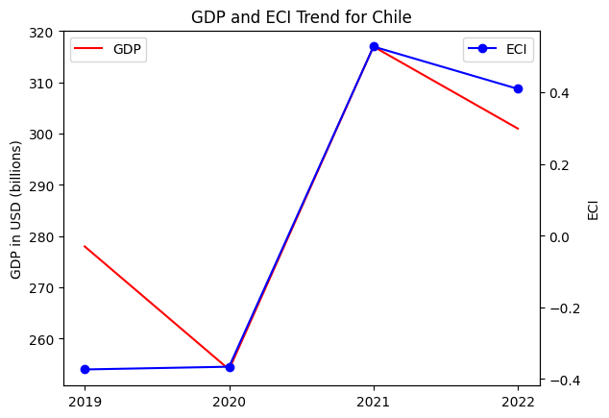
Figures 3a and 3b. GDP Growth and ECI for Chile (left: 2013-2018; right: 2019-2021)

3. Production Analysis

3.1 Product Categorization
Our main data source in this research is the UN Comtrade Website (https://comtrade.un.org), which provides us with valuable information on countries’ export values on an annual basis, including highly specific export data for more than 5000 categories of products. In order to have a holistic vision of the product space of a country, however, a level of categorization is required. Products in our data source are labeled from 010000-999999, with the first two digits representing a general category to which the product belongs. Based on the 99 categories extracted from the label, we further group the products into the 18 most widely-accepted industries, as summarized in Table 1.

Note that the High-complexity Products industry group is not a distinct industry but rather an aggregated industry that encompasses the most complicated products from the most technologically-advanced industries (as measured by PCI). This industry serves as an indicator for us to quantitatively evaluate how well a country has performed in developing cutting-edge technologies and closing its technological gap with advanced economies, which has become a topic of wide concern today. Indeed, when we rank the 18 categories based on PfCI (an equivalent concept of PCI as calculated based on the 18 categorized product groups), the High-complexity Products industry has the highest PfCI among all industry groups.

Category | Description
Animals and By-products | All kinds of meat, livestock and related by-products
Vegetables, Fruits and Plants | All kinds of plants, edible vegetables and fruits
Food and Preparations | Edible preparations, raw cooking materials and appliances
Clothing and Accessories | All kinds of fabrics, filament, clothing and accessories
Textiles | All kinds of textile articles and related products
Wood Products | Book, paper and other elementary products related to wood
Metals | Mining of all sorts of raw Metals
Refined and Processed Stones | Refined or processed stone products such as pearl and ceramics
Energy Drilling and Mining | Mining industry for energy, minerals, stone materials, etc.
Daily Instruments | Basic daily instruments such as sport requisites, timing and measuring tools
Raw Manufacturing | Basic products made from plastic, rubber, leather, etc.
Chemical Manufacturing | Advanced chemical products and pharmaceutical products
Chemicals | Raw chemical materials and by-products
Machinery and Construction | Machinery and mechanical appliances, including electrical equipment
Transportation | Vehicles and locomotives including aircraft, ship, railway, etc.
Weapons | Explosives, arms and ammunition
Services and Utilities | Financial, business, legal, communication, travel Services and Utilities, etc.
High-complexity Products | Agglomeration of advanced products with highest PCIs
Table 1. Categorization of Products

We further observe a positive correlation between the GDP and the export of High-complexity Products. A higher adjusted R-square exists between GDP and High-complexity Products exports, indicating that more successful economics, as measured by GDP, tend to be those that are capable of producing and exporting High-complexity Products as we define them. Tables 2a and 2b show the OLS results in a universe of 107 and 21 typical countries respectively.

 | High-complexity Products | Food and Preparations | Animals and By-products
Adj. R-squared | 0.075 | 0.006 | 0.002
F-statistic | 9.556 | 1.638 | 1.175
No. Observations | 107 | 107 | 107
Table 2a. OLS Regression Results of GDP against Percentage Volume of Exports

 | High-complexity Products | Food and Preparations | Animals and By-products
Adj. R-squared | 0.149 | 0.003 | -0.012
F-statistic | 4.510 | 1.059 | 0.7542
No. Observations | 21 | 21 | 21
Table 2b. OLS Regression Results of GDP against Volume of Percentage Exports

3.2 Realized Industry Development
Based on the aforementioned product categorization, we aim to capture Chile's realized industry production strategy between 2013 and 2022 on a complexity level. In Hausmann and Hidalgo (2009), distance is defined to be a measure of how far a country is from a certain product, not in its product space. We extend this concept to all product groups and quantify how technically equipped a country is to develop the corresponding product groups. In other words, the shorter the distance between a country and a product group, the more capable a country is of developing products within that group. Defining this net distance change as the Realized Industry Development (RID), our export data allow us to calculate and compare the RID of Chile and the 18 product groups in 2022 and 2018 through the difference, where a positive RID indicates a shortening of the distance (i.e., advancement of the industry), and a negative RID indicates the reverse. It is notable that the number of industries with positive RID has remained the same from from 2018 to 2022.

Category | RID (2022) | RID (2018)
Daily Instruments | -0.028890 | -0.010713
Chemicals | 0.008113 | 0.015096
Weapons | -0.078197 | -0.039482
Wood Products | 0.001685 | -0.002953
Transportation | 0.003401 | 0.050262
Machinery and Construction | 0.031155 | 0.004316
Metals | -0.012544 | -0.001646
Raw Manufacturing | -0.008961 | 0.002679
Services and Utilities | 0.007982 | 0.064776
Clothing and Accessories | -0.004641 | -0.011321
Chemical Manufacturing | -0.015455 | -0.011543
Food and Preparations | -0.007814 | 0.014151
Textile | 0.020613 | 0.008212
High-complexity Products | -0.023593 | 0.039611
Vegetables, Fruits and Plants | 0.022655 | 0.031425
Animals and By-products | 0.014762 | -0.001498
Energy Drilling and Mining | 0.000120 | -0.029164
Precious Stones | 0.036037 | -0.029164
Table 3. Realized Industry Development (RID) of Chile

3.3 Regional and Global Comparison
Tables 4a-4b below summarize how the production strategy adopted by Chile compares with selected leading economies in the world across different years, as measured in RID. Leading economies such as France, Greece, and Portugal gave a considerable level of attention to more advanced product groups such as Services and Utilities, Energy Drilling and Textiles in 2022.

Ranking | France | Greece | Portugal
1 | Services and Utilities | Energy Drilling | Textile
2 | Precious Stones | Wood Products | Fruit and Plants
3 | High-complexity Products | Services and Utilities | Daily Instruments
4 | Machinery & Construction | Clothing & Accessories | Clothing& Accessories
5 | Animals and By-products | Wood Products | Transportation
Table 4a. RID Comparison across Leading Economies (2022)

Table 4b further examines Chile’s development strategy against those of emerging economies on a global scale. Reasonably, emerging economies such as China and Singapore have devoted the majority of their efforts to intermediate industry groups, showing moderate shifts in strategies over the course of three years.

Ranking | China | Singapore
1 | Chemicals | Transportation
2 | Daily Instruments | High-complexity Products
3 | Transportation | Energy Drilling & Mining
4 | Raw Manufacturing | Machinery& Construction
5 | Weapons | Chemical Manufacturing
Table 4b. RID Comparison across Emerging Economies (2022)

Tables 4c-4d further examine Chile's development strategy against those of emerging economies from the previous time period.

Ranking | France | US | Germany
1 | High-complexity Products | Services and Utilities | High-complexity Products
2 | Chemical Manufacturing | Weapons | Transportation
3 | Daily Instruments | Raw Manufacturing | Wood Products
4 | Animals and By-products | Precious Stones | Metals
5 | Food and Preparations | Animals and By-products | Food and Preparations
Table 4c. RID Comparison across Leading Economies (2018)

Ranking | China | South Korea | Singapore
1 | High-complexity Products | Transportation | Transportation
2 | Transportation | Textile | High-complexity Products
3 | Machinery and Construction | High-complexity Products | Precious Stones
4 | Energy Drilling and Mining | Chemical Manufacturing | Daily Instruments
5 | Daily Instruments | Machinery and Construction | Services and Utilities
Table 4d. RID Comparison across Emerging Economies (2018)

4. Product Space Design

4.1 Suggested Development Vector
As outlined above, distance gives us an idea of how far each new product is from a country’s current mix of exports. As defined in Hausmann and Hidalgo (2009), distance is “the weighted proportion of products connected to goods p that country c is not exporting, i.e., MCP = 0.” Based on this definition, the distance between a country and any product that the country is currently exporting (i.e., the country is a significant exporter of the product as compared to the global average) is zero. Similarly, opportunity gain quantifies the contribution of a new product in terms of opening up the doors to more and more complex products. Intuitively, a product that a country is currently exporting (i.e., MCP = 1) has an opportunity gain of zero. An unreasonable investment in a certain product p would lead to a relative decrement in the export of more profitable products and therefore lead to a negative opportunity gain of product p. The opportunity gain is not the only estimator of a country’s level of economic development. However, among countries with comparable economic strength, those having higher ECI, or in other words, more reasonable economic structures are often in better shape.

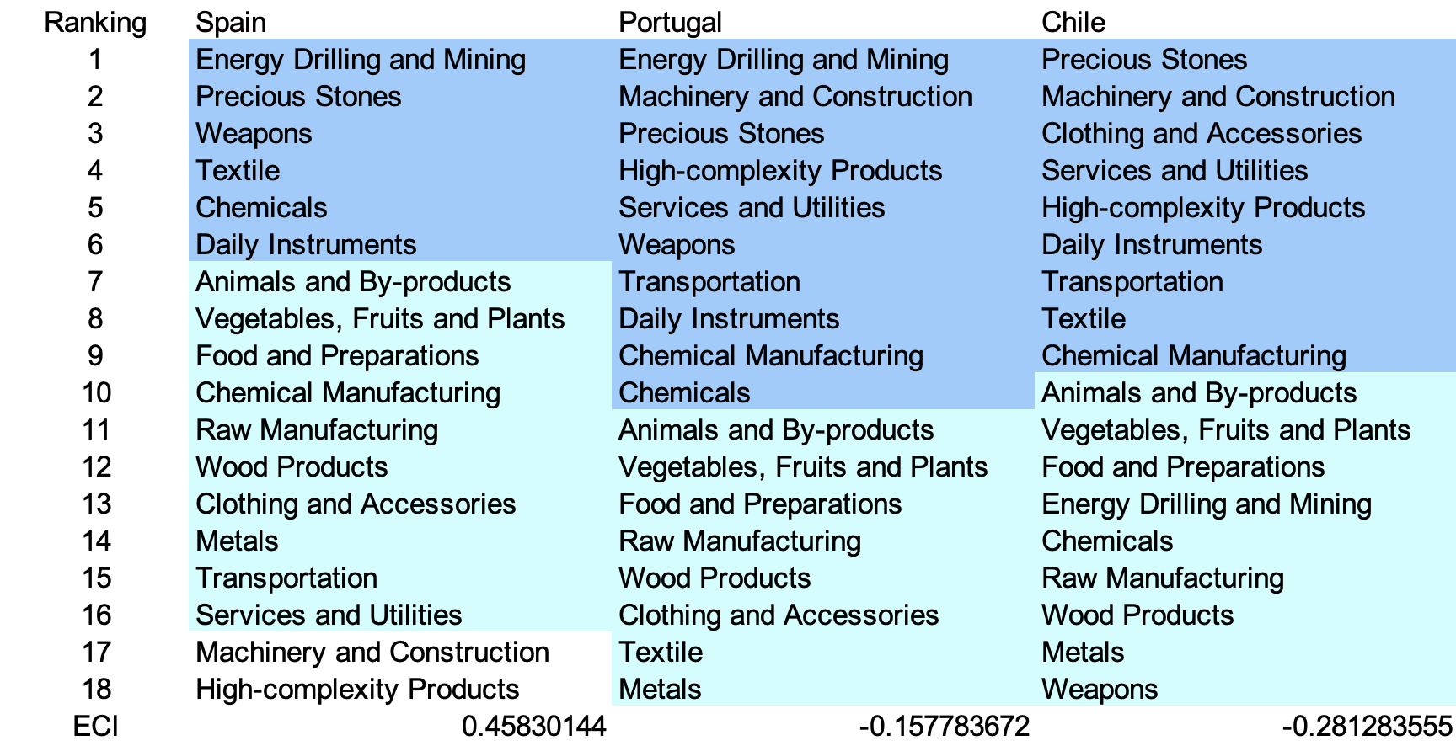
Table 5a. Opportunity Gain Ranking on a Comparable Scale (2013)
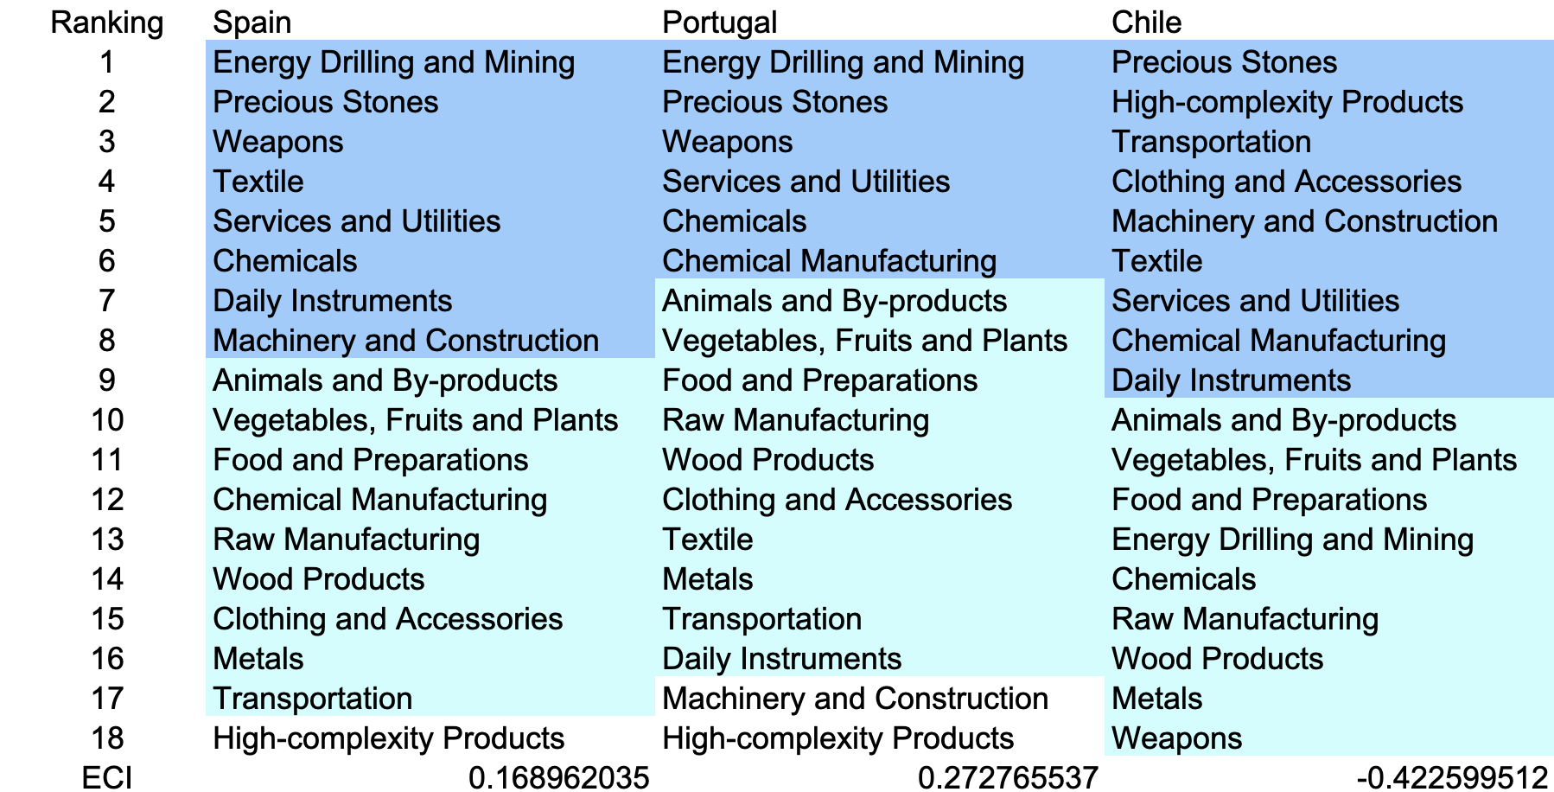
Table 5b. Opportunity Gain Ranking on a Comparable Scale (2018)

Rank | Chile | Argentina | Bolivia | Peru
1 | Services and Utilities | Transportation | High-complexity Products | High-complexity Products
2 | High-complexity Products | High-complexity Products | Services and Utilities | Services and Utilities
3 | Precious Stones | Daily Instruments | Transportation | Transportation
4 | Transportation | Machinery and Construction | Daily Instruments | Chemical Manufacturing
5 | Daily Instruments | Chemicals | Chemical Manufacturing | Daily Instruments
6 | Machinery and Construction | Chemical Manufacturing | Machinery and Construction | Textile
7 | Chemical Manufacturing | Raw Manufacturing | Chemicals | Chemicals
8 | Weapons | Weapons | Animals and By-products | Clothing and Accessories
9 | Clothing and Accessories | Energy Drilling and Mining | Raw Manufacturing | Wood Products
10 | Textile | Wood Products | Metals | Machinery and Construction
11 | Raw Manufacturing | Clothing and Accessories | Wood Products | Raw Manufacturing
12 | Animals and By-products | Animals and By-products | Clothing and Accessories | Animals and By-products
13 | Vegetables, Fruits and Plants | Vegetables, Fruits and Plants | Textile | Vegetables, Fruits and Plants
14 | Food and Preparations | Food and Preparations | Vegetables, Fruits and Plants | Food and Preparations
15 | Energy Drilling and Mining | Services and Utilities | Food and Preparations | Energy Drilling and Mining
16 | Chemicals | Metals | Energy Drilling and Mining | Metals
17 | Wood Products | Textile | Weapons | Weapons
18 | Metals | Precious Stones | Precious Stones | Precious Stones
ECI | 0.410178 | -0.103375 | 1.052018 | 0.778455
Table 5c. Opportunity Gain Ranking on a Comparable Scale (2022)
We define the ranking of opportunity gain for a country c, as the Suggested Development Vector (SDV) of c. Tables 5a-5c summarize how the SDV of Chile compares with a selected group of comparable and leading economies in the world, with the industry groups ranked in decreasing order of significance.

Dark blue indicates positive opportunity gains, light blue indicates zero opportunity gains, and white indicates negative opportunity gains. The result shows that leading countries barely have any industries with positive opportunity gain. In other words, those countries are already in the most stable and efficient economic structure. Without the necessity of economic transition, those countries merely need to maintain a steady and balanced economic development. In contrast, developing countries have nearly half of industries with positive opportunity gain and share common interests in High-complexity Products and Services and Utilities industries. It can be concluded that Chile shares the characteristics of developing countries, with a balanced economic structure that leans towards moderate complexity-level industries.

Table 6. SDV of Other Sample Countries (2013)

4.2 Budgeted Industry Development Strategy and Interpretation
The optimal budgeted industry development strategy aims to solve the most efficient allocations under the budgeted constraint of different situations of heuristic total export growth. In order to obtain such an allocation portfolio, we formulate an optimization problem as the following:



where k(x) is the second largest eigenvector of $M_{CC'}$ after adding $x$ to the original export vector, C is the country that we are interested in, P is the product space, B is the heuristic budget.

If we can solve this problem, then we can know what the largest ECI to which a country can improve. Accordingly, the optimal solution $x*$ that we obtain here is exactly our optimal allocation. However, the biggest problem is that the objective function is not convex. Therefore, we cannot apply the classical tools for convex optimization to this problem. In order to solve this problem, our idea is to use a greedy algorithm. The way that we apply the greedy algorithm is that firstly we separate the total budget into k equal parts, and then for the first equal part we try to search for the product that can optimize our objective function by iterating through each $p∈P$. After we find the optimal product p for this equal part, we add the amount back to the export value of this product p and update the ECI for this country. If we observe that ECI does not change after iterating all the products, then we can add up one more equal part to invest. Until we find there is an ECI increment, we add the amount now to that product. The equal rest parts can be done in the same way.

By definition, a greedy algorithm is a kind of local search algorithm that is possible to run into a local minimum. Therefore, for local search algorithms, one typical way to keep it away from the local minimum is to enhance the vision of the algorithm by looking more steps forward. In our setting, whenever we obtain an increment of ECI, we mark down the required amount of export growth. Simultaneously, we continue searching for the next ECI increment point, compare the ratios of these two possibilities and pick the largest one. The ratio is defined as the following:

where ${ECI}_{p}$ is just the ECI of the country after adding some amount of export increment to product $p$, which is exactly the amount that is able to make ECI change. Also, we can express it in the way of $||$$x_{p}-x_{0}$${||}_{1}$.

In this way, we can obtain a further sighted greedy algorithm. Also, the number of parts that we would like to separate the budget into also matters. In order to solve this problem, we added a stabilizer on top of the enhanced greedy algorithm by running the algorithm for different numbers of parts and selecting the portfolio with the largest ECI increment and most complex economic structure.

Besides, it is quite common that there is a surplus in the budget. To deal with the surplus, we just add it to the product which needs the least amount of dollars to make $M_{cp}$ = 1 (i.e., the smallest amount of required export increase).

Economic Panel
As stated above, the enhanced greedy algorithm is developed mainly for solving the optimal allocation strategy. In order to visualize this allocation, an economic panel is created, consisting of a pie chart, a line chart and a table. First, a pie chart is used to show the percentage of each product in the optimal portfolio. The number located in the center of the circle denotes the heuristic growth of total export, which is also our budget. Each category in the chart has a determined percentage of the allocated budget. The lines below the pie charts show how the ECI changes during the searching process of the greedy algorithm. Even though sometimes an increase of the export by 15% or 20% does not seem reasonable to developed countries, yet it can also give a sense of how a country should develop in the long term. Eventually, the graph in the end is just for numerical explanation for the pie charts.

Interpretation
For the purpose of a clear explanation of the line charts, we label all the products in Table 7. Please refer to this table when trying to understand the investment trajectories in the line charts.

Label | Product Names
1 | Animal and By-products
2 | Vegetables, Fruits and Plants
3 | Food and Preparations
4 | Energy Drilling and Mining
5 | Chemicals
6 | Chemical Manufacturing
7 | Raw Manufacturing
8 | Wood Products
9 | Clothing and Accessories
10 | Textile
11 | Metals
12 | Machinery and Construction
13 | Transportation
14 | Weapons
15 | Daily Instruments
16 | Precious Stones
17 | High-complexity Products
18 | Services and Utilities
Table 7. Products Labeling

Figures 4a-4c show an economic panel for Chile in 2013, 2018, and 2022. We can see that for different percentages of heuristic total export growth, the ECIs of Chile actually have different increments. Across all 3 years, an increase in investments corresponds to an increase in the number of industries. We note that Services and Utilities are a strong focus in 2013 and 2018 but do not appear in 2022. Instead, Chile should invest in Precious Stones and Textiles, which are lower-complexity industries

For 2013, 5 percent export growth results in a ECI improvement pattern starting from around -0.28 and ends at around 0.02. As the budget is increased to 10 percent export growth, the ECI of Chile can achieve a slightly higher level, which is around 0.16. With much more growth budget, like 15 or 20 percent growth, Chile is able to achieve an even much higher stage, which is around 0.41.

For the case of 5 percent export growth, clothing and accessories, services and utilities account for most of the portfolio. For 10 percent export growth, the portfolio becomes more diverse. In addition to the products mentioned before, chemicals and daily instruments are added as main components as well. With 15 percent growth, one of the main factors in the portfolio of 10 percent growth budget, daily instruments, is replaced by machinery and construction. When the budget increases to 20 percent, the portfolio becomes pretty comprehensive, which mainly contains chemicals, animal and by-products, textile and machinery and construction etc. In these four ECI improvement trajectories, we also notice that the largest improvement comes from raw manufacturing, suggesting that with a low economic improvement anticipation, Chile should focus more on developing these products. A more detailed numerical representation of the portfolio is shown in Table 8a.

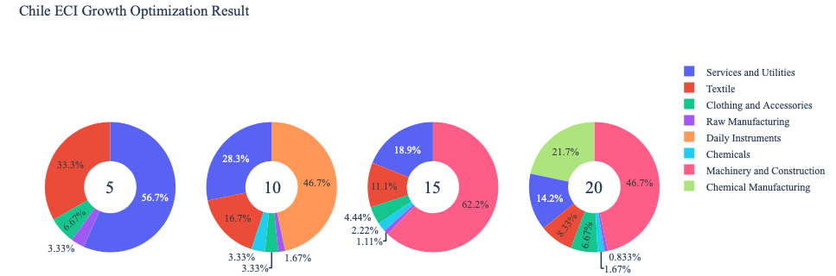

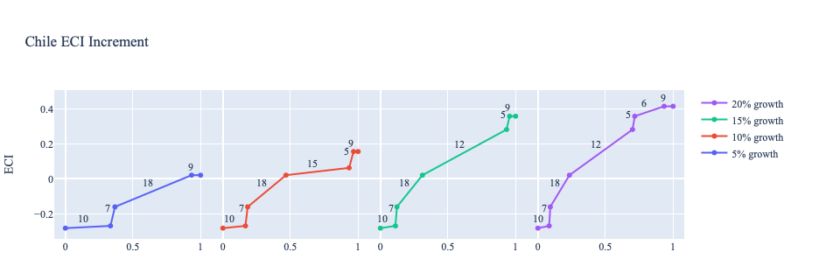
Figure 4a. Greedy-Based ECI Improvement Results of Chile with Different Budgets (2013)

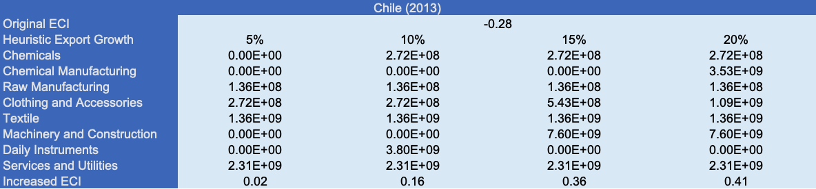
Table 8a. Portfolio of Chile (2013)

For further suggestions on Chile’s development in the future. We also offer the optimization result based on its export data in 2018. Below is the economic panel for Chile in 2018. With 5 percent export growth, Chile should mainly focus on developing clothing and accessories as well as services and utilities, which is similar to the result in 2013. As the budget grows to 10 percent, the main components contain precious stones, raw manufacturing, chemical manufacturing and services and utilities. For situations with higher budgets of investment, like 15 or 20 percent growth, although improvement patterns are similar, the portfolio obtained from a higher budget tends to be more comprehensive. With 15 percent export growth, the main components in the portfolio include daily instruments, chemical manufacturing and services and utilities. However, for the case of 20 percent growth, the allocation puts more weight on services and utilities, rather than daily instruments. A more detailed numerical representation of the portfolio is shown in Table 9.

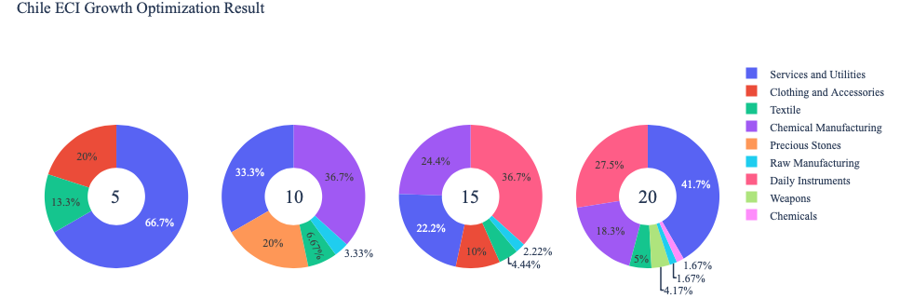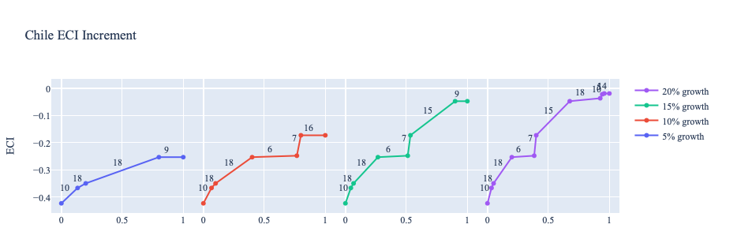
Figure 4b. Greedy-Based ECI Improvement Results of Chile with Different Budgets (2018)

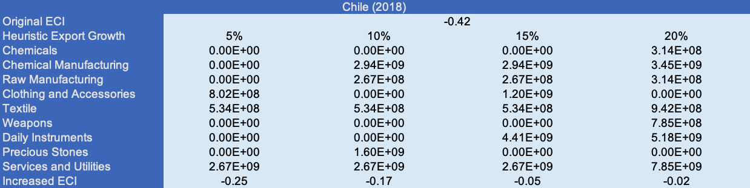
Table 8b. Portfolio of Chile (2018)

To compare with the performance in 2013 and 2018, we also re-examine suggested strategies for 2022. For 2022, a 5 percent increase in export would emphasize Precious Stones and Textiles, followed by Chemicals for 10, 15, and 20 percent export growth, and Food and Prepartions for 15 and 20 percent. These strategies go in line with the suggested trajectories based on ECI. The appearance of Chemicals in high growth percents suggests that Chile is a rapidly advancing country that has opportunity to develop high-complexity industries if it continues. A more detailed numerical representation of the portfolio for Chile is shown in Table 8c.
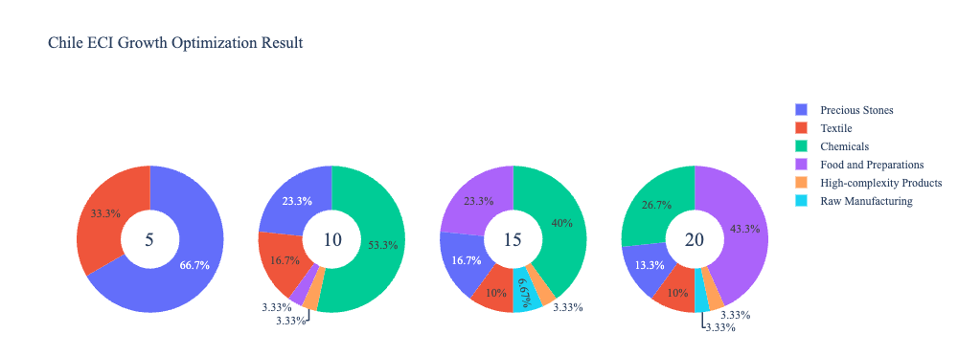
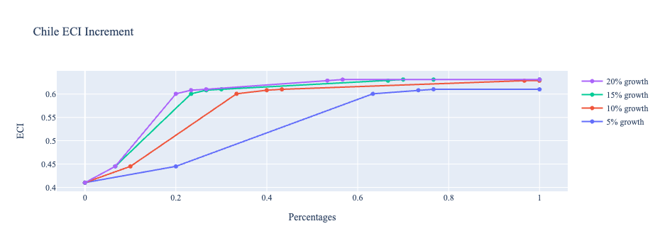
Figure 4c. Greedy-Based ECI Improvement Results of Chile with Different Budgets (2022)

Chile (2022)
Original ECI | 0.410178
Heuristic Export Growth | 5% | 10% | 15% | 20%
Food and Preparations | 0.00E+00 | 3.65E+08 | 5.24E+09 | 9.49E+09
Chemicals | 0.00E+00 | 5.84E+09 | 8.98E+09 | 5.84E+09
Raw Materials | 0.00E+00 | 0.00E+00 | 1.50E+09 | 7.30E+08
Textile | 3.10E+09 | 1.83E+09 | 2.25E+09 | 2.19E+09
Precious Stone | 6.21E+09 | 2.56E+09 | 3.74E+09 | 2.92E+09
High-complexity Products | 0.00E+00 | 3.65E+08 | 7.49E+08 | 7.30E+08
Increased ECI | 0.61025234 | 0.62874075 | 0.63118791 | 0.63118791
Table 8c. Portfolio of Chile (2022)

4.3 Sensitivity Analysis and Contingency Strategy
In the following section, our broad aim is to understand how sensitive Chile is to changes in export in various industries. While the Economic Complexity Index has been shown to contain valuable information about the economic strength/capacity of a country, little has been said as to the stability of the measure itself. We seek to uncover the main drivers of stability under a country's ECI score and better understand longer-term projections for ECI growth. Additionally, gaining an intuition on the industries that are bolstering an economy and the industries that offer the greatest return per unit of investment is best done through visualization of industry-specific sensitivity. To this end, we have developed two categories of sensitivity analysis.
ECI Sensitivity Graph
First, in order to assess the effect particular industries have on each respective country, we developed ECI Sensitivity graphs (Figure 5). We use the shocking methodology to increment or decrement an industry’s export level by a certain percentage and recalculate the ECI, all else being equal. While freezing the export dynamics of the rest of the world and enacting an instantaneous shock in export for a particular industry and country may not reflect real-life dynamics, what it does offer us is an understanding of a country’s level of dependency on an industry in the context of ECI. The shocking is done in small percentage increments in order to smooth out the resulting curve. Additionally, a recurring theme one will see is that for most industries, a breaking point occurs where the ECI either jumps upwards or downwards, creating a hockey stick shape rather than a linear trend. While the inflection point may not be accurate in the context of real life, comparing the various inflection points across industries can give us valuable insight.

Figure 5. Sample ECI Sensitivity Graph (2018)
The graphs are formulated as follows. There are six ECI Sensitivity graphs, two for each of the following years: 2022, 2018, and 2013. The first chart, Incremental ECI Sensitivity, shows positive shocking in which export numbers are shocked upwards per industry. The X-axis is in terms of percentage shock per current dollar value of export. The Y-axis is the recalculated ECI level post-shocking. The second chart, Decremental ECI Sensitivity, follows the same format except the X-axis represents negative shock. In other words, exports for each industry are decremented, and the ECI is accordingly recomputed.
SDV Sensitivity
Secondly, we analyze the sensitivity of the SDV to changes in export levels. The goal is to understand how export level changes for a particular industry can affect the marginal opportunity gain for other industries. We will be using specifically High-complexity Products and Food and Preparations as our base industries. We will be increasing or decreasing the absolute export level in both of these industries and observing the effects on the SDV.
When the opportunity gain of an industry is negative, the SDV sensitivity approximates how an over-development of the industry jeopardizes the economic structure of a country. When the opportunity gain of the industry is zero, the SDV sensitivity determines whether the further development of the industry shapes the country with a better economic structure and predicts how the SDV would change accordingly. Specifically, as we reduce the export of such an industry to 25% - 50% of its original value, a few other industries originally with negative opportunity gain could likely become profitable.
Similar to the ECI sensitivity graphs above, we will be shocking the export of High-complexity Products and Food and Preparations in small percentage increments. A new SDV, represented by a new column in the charts, is recorded only when a certain level of shock changes the structure of the SDV. In effect, we are incrementing or decrementing export levels of two industries until the marginal opportunity gain of any industry changes in category (positive, negative, or neutral). Below is an example of an SDV Sensitivity chart with Positive Shocking. Industries with positive marginal opportunity gain are colored blue, neutral is colored white, and negative is colored red.


Table 9. Sample Incremental SDV Sensitivity for High-Complexity Products (2018)

Contingency Plan
The Contingency Plan aims to present a set of solutions with respect to upheavals in different industries. Instead of compensating for the declining production directly, the best strategy is to develop those incipiently profitable industries. In this manner, we can derive a contingency strategy for countries to deal with possible abrupt declines of crucial industries. In some cases, the SDV remains unchanged even when a zero-opportunity-gain industry declines to 20% in terms of export. We can then conclude the industry is not indispensable to the country. As a clarification, the three consecutive N/As mean that the country doesn’t even need to respond to a collapse in the industry. Countries tend to have distinct solutions to the ups and downs of the same industry. To create the contingency strategy table, we decrease the export level for each industry in the country’s current production space by 60% respectively. The three highest-ranking industries in the new SDV are then returned.

Product Names | 0 | 1 | 2
Animal and By-products | Services and Utilities | Daily Instruments | Weapons
Vegetables, Fruits and Plants | Services and Utilities | Daily Instruments | Weapons
Food and Preparations | Services and Utilities | Daily Instruments | Weapons
Energy Drilling and Mining | Services and Utilities | Daily Instruments | Weapons
Chemicals | Services and Utilities | Daily Instruments | Weapons
Chemical Manufacturing | Services and Utilities | Daily Instruments | Weapons
Raw Manufacturing | Services and Utilities | Daily Instruments | Weapons
Wood Products | Services and Utilities | Daily Instruments | Weapons
Clothing and Accessories | Services and Utilities | Daily Instruments | Weapons
Textile | Services and Utilities | Daily Instruments | Weapons
Metals | Services and Utilities | Daily Instruments | Weapons
Machinery and Constructions | Services and Utilities | Daily Instruments | Weapons
Transportation | Services and Utilities | Raw Manufacturing | Daily Instruments
Weapons | Services and Utilities | Daily Instruments | Transportation
Daily Instruments | Services and Utilities | Weapons | Transportation
Precious Stones | Services and Utilities | Daily Instruments | Weapons
Daily Instruments | Services and Utilities | Daily Instruments | Weapons
Services and Utilities | Daily Instruments | Weapons | Transportation
Table 10. Sample Contingency Strategy (2018)

4.3 Sensitivity Analysis Results and Interpretation
We examine Chile's ECI Decremental and Incremental Sensitivity Charts for 2022. An increase in High-complexity Products will lead to the highest change in ECI, followed by Precious Stones. The low sensitivity effect of manipulating most industries contrasts previous years. Increases in Precious Stones will likely lead to increases in ECI, which is concurrent with our previous analysis. On the other hand, increasing High-complexity Products leads to a decrease in ECI, which can be interpreted as a warning to invest in moderate-complexity products first, such as Textiles or Precious Stones. For the negative shock cases, Energy, Drilling, and Mining and Chemicals become most impactful. This is interesting because both are relatively complex industries. In 2018, a negative shock to Energy, Drilling, and Mining lead to increases in ECI but in 2022, the same effect leads to decreases. This suggests that the industry has become more integral to the national economy.

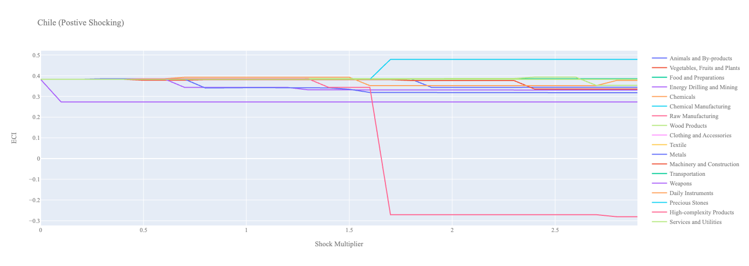
Figure 6a. Incremental ECI Sensitivity for Chile (2022)
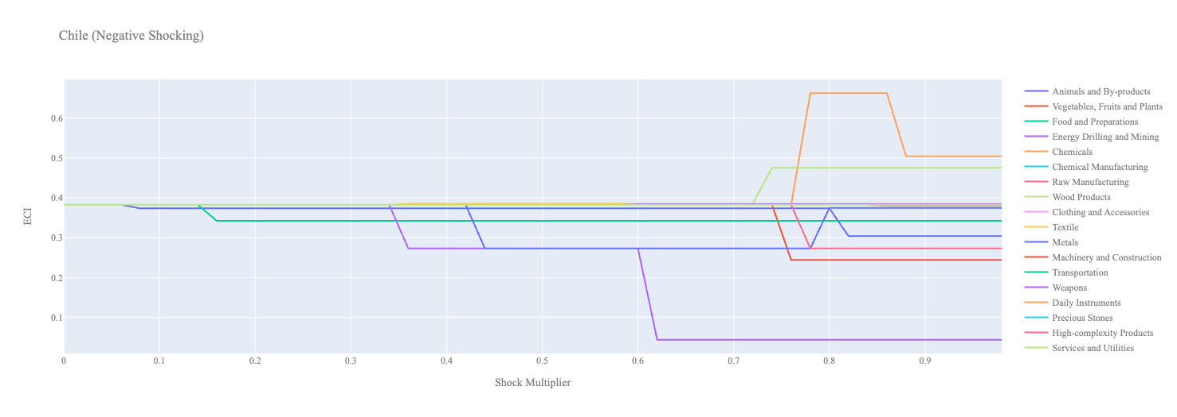
Figure 6b. Decremental ECI Sensitivity for Chile (2022)

Below is Chile’s 2018 ECI Sensitivity Charts. Firstly in the positive chart, we notice immediately an increase in export in none of the industries lead to an increase in ECI score. We need to increase exports in a combination of industries in order to truly increase ECI score. Additionally an increase of export in many of the industries lead to slight decreases in ECI.

Next we consider Chile’s 2018 Negative Shock chart. We see that Chile is especially sensitive to drawdown in Raw Manufacturing, Weapons, and Chemicals suggesting that these are key industries for the stability of the country’s ECI score.

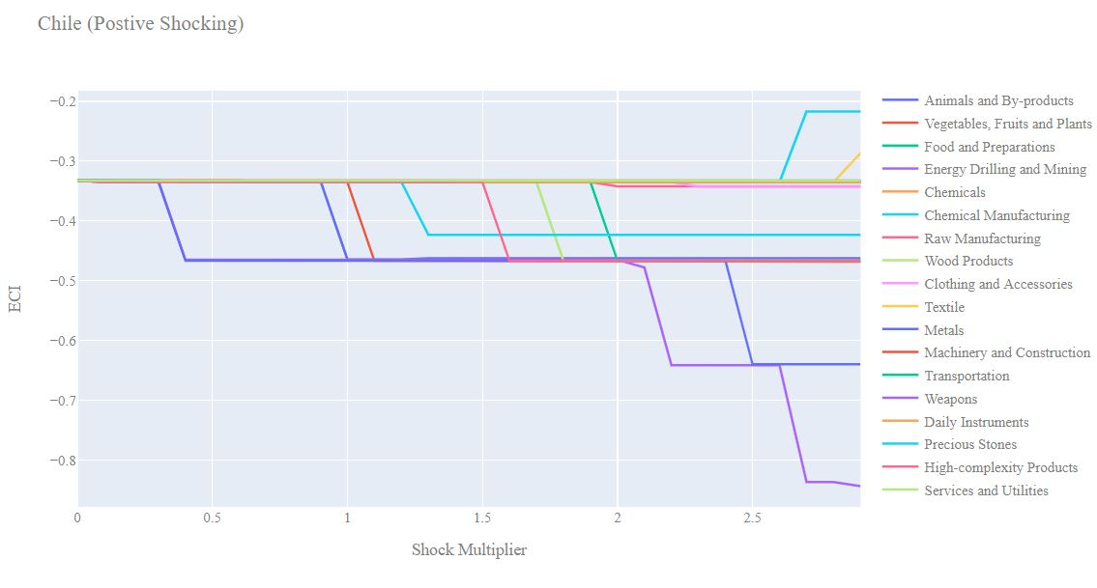
Figure 7a. Incremental ECI Sensitivity for Chile (2018)

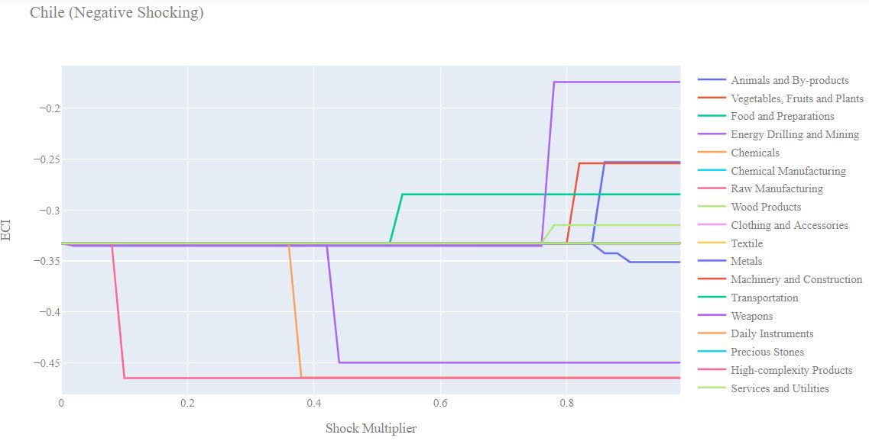
Figure 7b. Decremental ECI Sensitivity for Chile (2018)

Next we consider the 2013 ECI Sensitivity graphs. In the positive shocking case we see very similar behaviour as in 2018 although it is quite amplified. We see that increase in export for most industries actually decreases the ECI score.

In the negative shocking case we see again Chile is quite sensitive to decreases in Raw Manufacturing and Chemicals, even more so than we see in 2018. Large decreases in Energy, Drilling & Mining seem to increase the ECI score suggesting that this is a suboptimal industry for Chile to expand into.
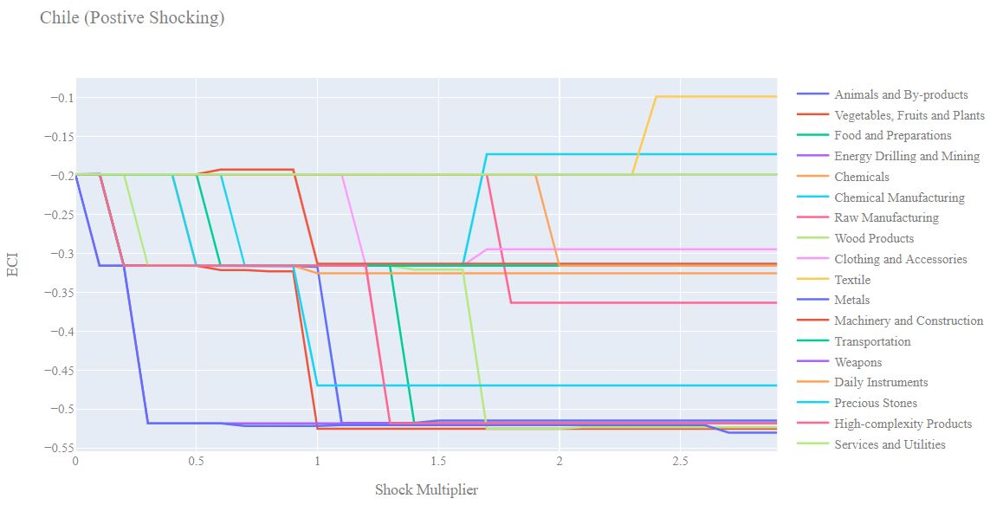
Figure 8a. Incremental ECI Sensitivity for Chile (2013)

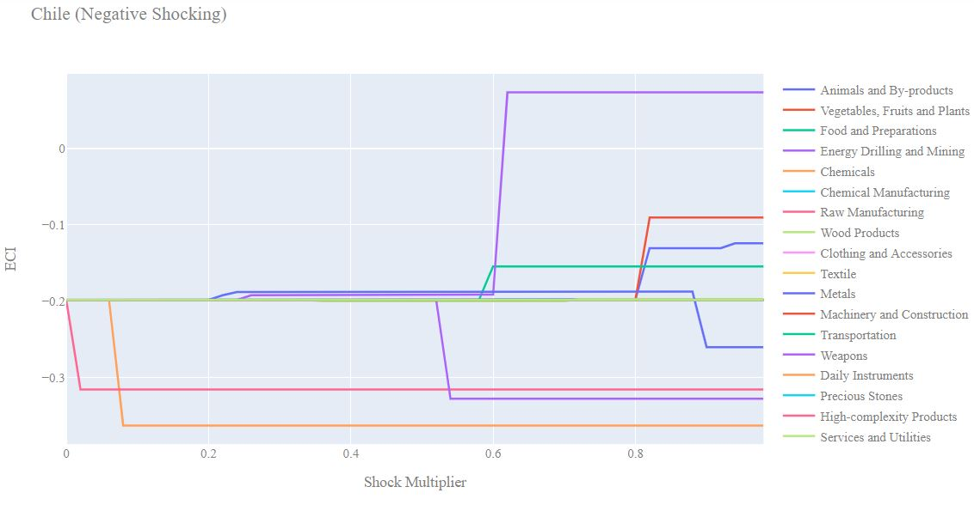
Figure 8b. Decremental ECI Sensitivity for Chile (2013)

4.4 Contingency Strategy
Decreasing export of each industry in Chile’s current production space by 60% respectively, we derive the contingency strategy shown below.

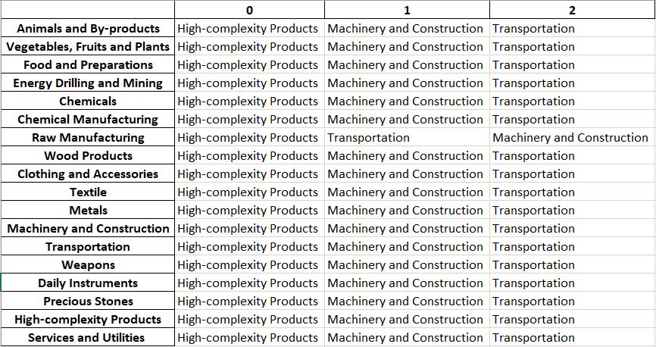
Table 13. Chile’s Contingency Strategy (2018)

5. Macro-level Predictions

5.1 Structural Optimality Index
ECI sensitivity described in the section before has proven to be a significant factor in deciding the economic outcomes of countries. In order to quantitatively evaluate how effective our development strategies are and how deviations from the suggested developmental path will lead to suboptimal growth results, we define the measure – Structural Optimality Index (SOI) – on a country level as the Adjusted R-Square obtained from regressing the country’s realized industry development over the suggested development strategy. Both strategies are quantified in nature, with the realized development represented by increasing export in every major industry group and the suggested development strategy represented by the opportunity gains of developing the corresponding industry groups as calculated in previous sections. The adjusted R-square from the regression thus provides us with a quantified measure of how the development path adopted by the country has fitted with/differed from calculations on a complexity level.

After obtaining this measure for all countries in our database, we further regress countries’ five-year economic growth, which is defined as the percent increase in GDP (USD), over their SOI. Figure 9 illustrates the regression output, which shows a strong positive correlation between countries’ SOI and their five-year GDP growth, significant at the [Percentage]% level and achieving an adjusted R² of [Percentage]%. In other words, the more a country develops, as suggested by calculations on a complexity level, the better economic outcomes it achieves.

Table 14: OLS Regression Results
Dep. Variable: GDP | F-Statistic: 5.963
R²: 0.054 | Prob (F-Stat): 0.0163
Adj R²: 0.045 | No. Observations: 106


Figure 9. Regression of Five-Year GDP Growth over SOI (2013-2018)

5.2 SOI of Chile and Its Implications
During the first examined period, Chile, for instance, has an average level of structural optimality as compared with its developed peers. As the regression in Figure 10a suggests (the red curve represents export increase and the blue curve stands for opportunity gain of the corresponding industry), Chile demonstrates an average level of correlation with the suggested developmental path, having an adjusted R-square of around 3.34%

Chile ranks in the second quartile among all countries in terms of SOI and has made a average rate of economic progress among its emerging peers from 2013 to 2018 with a 5-year GDP growth rate of 19.8%, which is consistent with the regression result in Figure 4b. This is in direct contrast to emerging economies such as Turkey, where there is a high SOI of around 21.8% and corresponding GDP growth of 37.7% from 2013 to 2018, making it one of the fastest developing economies during the period.

Specifically, Chile's moderate economic progress from 2013 to 2018 can be at least partially explained by a development strategy that demonstrates a considerable but not perfect level of matches with our suggested developmental path. In specific, Chile invested heavily in the Services and Utilities industry, while it should have focused more on moderately complex industry groups such as Precious Stones industry.

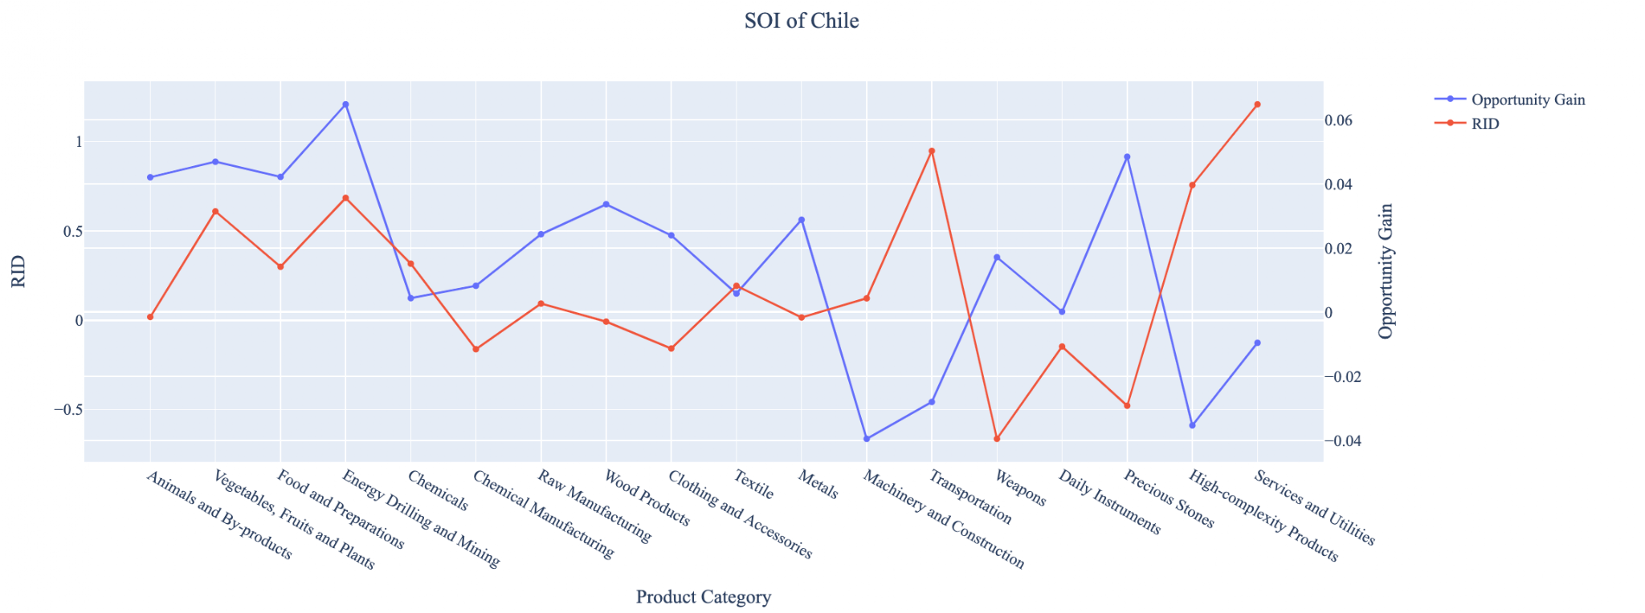
Figure 10a. SOI of Chile (2013-2018)

For the 2019-2022 years, Chile had a strong presence in the Precious Stones and Machinery and Construction industries, which is partially aligned with our previously recommended development strategy. We attribute Chile’s small GDP growth and significant ECI growth to this alignment. In the future, Chile should continue to invest in Machinery and Construction because it demonstrates high opportunity gain. It should take a more conservative approach to Precious Stones; while it has previously been a rewarding industry, it now has lower opportunity gain. Additionally, in the budget allocation section of this report, we also saw that Precious Stones played a progressively smaller role with each increase in export growth. Chile should also consider other moderately complex industries with high opportunity gains, such as Daily Instruments, to improve its growth.

Higher than before, its adjusted R-squared value of 11.28% now indicates a high correlation between the GDP growth and the implemented development path. Progress is slow on a global scale during this period, but Chile demonstrates a greater ability to adjust to negative economic shocks by improving SOI and increasing GDP growth than it did between 2013 and 2018.

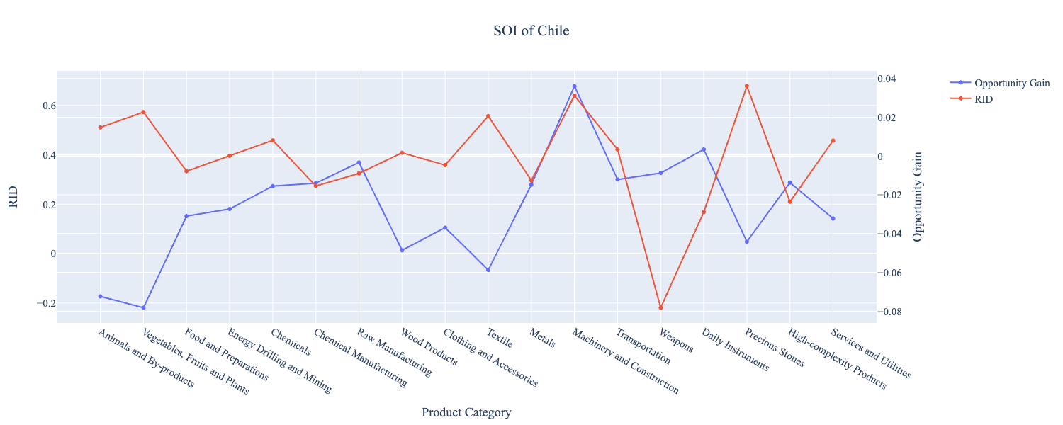
Figure 10b. SOI of Chile (2019-2022)

6. Concluding Remarks

In conclusion, Chile has demonstrated a moderate level of economic growth in terms of annual GDP increase during the period from 2013 to 2018, concurrent with an increase in economic complexity as compared with other emerging economies. For 2019-2021, the growth in GDP has increased alongside a large boost in ECI, in line with its comparable countries and higher than some of the leading economies in the world.

The mixed progress during the first period, we believe, can be partially explained through the analysis of the economic and product complexity structure of Chile on the industry group level. The product classification system we adopt allows us to measure the realized industry development for various industry groups and to observe that Chile consistently relied on developing the Services and Utilities and Transportation industries in 2013 to 2018, while its developed counterparts and emerging economies around the globe adopted much more complex and progressive paths.

Based on our analysis of the opportunity gain and a sensitivity analysis of major industry groups for 2013-2018, Chile can further its gains by prioritizing a combination of sectors, most notably Services and Utilities and Chemical Manufacturing and Precious Stones. We further note that Chile has a slightly mismatched development strategy that indicates an average (compared to other emerging economies) level of structural optimality on the complexity level, having an adjusted R-square of around 3.34%. Since a significant positive correlation exists between five-year GDP growth and the structural optimality index of an economy as we define and calculate, Chile indeed has a suboptimal growth experience as compared with fast-growing economies both on a regional scale and on a global scale, and has the potential to further its economic gains through industrial structure optimization as suggested in the paper.

During the second examined period from 2019 to 2021, Chile performed stronger than before and compared to other countries, particularly Bolivia and Peru. We infer that during the COVID-19 period, Chile focused on developing a mix of moderately complex industries with its fiscal stimulus package. We also note that Chile has increased its investment in the sectors identified earlier, leading to a strong boost from Precious Stones, but still leaving some room for additional strategic improvement. The opportunity gain in the SOI suggests that greater growth could have been achieved through Machinery and Construction, while the budget allocation suggests that slow or moderate growth can be maximized by continued investments in Precious Stones. The surprising growth also increased the adjusted R-squared value to 11.28% in 2021 from 3.34% in 2018, demonstrating the pursued strategies contributed to the GDP. With the revised focus, Chile has further potential to advance its economic growth to maintain its position among other countries to continue its ongoing economic expansion.

References

Hausmann, R., Hidalgo, C., Bustos, S., Coscia, M., Chung, S., Jimenez, J., Simoes, A. and Yıldırım, M. (2007). The Atlas of Economic Complexity. [online] Atlas.cid.harvard.edu. Available at: http://atlas.cid.harvard.edu/.

Balassa, B., “The Purchasing Power Parity Doctrine - A Reapprais- al,” Journal of Political Economy 72, 584-596 (1964).

Feenstra, R.; Lipsey, R.; Deng, H.; Ma, A. & Mo, H. “World Trade Flows: 1962-2000” NBER working paper 11040. National Bureau of Economic Research, Cambridge MA (2005).

United Nations Commodity Trade Statistics Database (http://comtrade.un.org/db/), accessed in August 2019.

The World Economic Forum, “The global competitiveness report,” (various years).

Barro, R. & Lee, J-W. “A New Data Set of Educational Attainment in the World, 1950-2010,” NBER Working Paper No. 1590 (2010).

Kaufmann, D. & Kraay, A. “Governance Indicators: Where Are We, Where Should We Be Going?” Policy Research Working Paper 4370. Washington, DC: World Bank (2008).

Hanushek, E.A. & Woessmann, L. “The Role of Cognitive Skills in Economic Development,” Journal of Economic Literature 46(3), 607- 668 (2008).

